Fullerton College
Division of Social Sciences

Political Science 150
Introduction to California Government
Online Course Syllabus

Jodi Balma
Office: 1425-C Campus e-mail: jbalma@fullcoll.edu
Office Phone: (714) 992-7522

General Information

Please read this syllabus carefully and refer to it during the course if you have any questions. Before you post a question in a discussion board or e-mail me a question, please check this syllabus first to see if you already have the answer before you.

This course is an introduction to the study of California state and local politics, exploring the political culture, processes, behavior, institutions, public policy, and distribution of power in California. Topics include the political culture of the state, the process of change, policy agendas, budgeting, and the current status of states within the federal system.

According to college guidelines, a student should expect to spend at least two hours studying outside of class for every hour in class. For this course a student is expected to spend 6 hours studying in addition to 3 hours in class for a total of 9 hours a week. Make sure you have allocated enough time in your schedule for this class.

This is an online course. Contrary to what many anticipate, this does not make it easier. This course is designed for self-motivated students who wish to proceed through the subject matter at their own pace. Keep in mind that independent study is not the best option for every student. The lack of scheduled class meetings means you are responsible for your own schedule. To succeed in this course, you must be independent, motivated and well organized, willing to learn in isolation, and your reading, studying, and analytical skills should be strong. Please give careful consideration to whether this is a format that will work for you. Marginal students just taking this class to avoid attending class or because they think it will be easy are strongly encouraged to drop now and enroll in a traditional on-campus class.

Student Learning Outcomes:
Students who complete this course will:
- Have a perspective on who governs the state of California;
- Have an understanding of their responsibilities as citizens;
- Have an understanding of the role of media in a democracy;
- Be acquainted with major political and governmental institutions in California and the United States;

Required Textbook
Van Vechten, Renee. California Politics: A Primer. (3rd Edition)
ISBN: 978-1483340135

Grades:
Assignment | Percent of Grade
Discussion Questions (6) | 30%
Exam #1 | 20%
Exam #2 | 25%
Exam #3 | 25%

Grade | Percent
A | 90 - 100%
B | 80 – 89%
C | 70 – 79%
D | 60 – 69%
F | 0 – 59%
Cheating and Plagiarism
All online tests are closed book and closed notes. All student work, including exams, discussion board postings, and papers must be their own work. Cheating and plagiarism will not be tolerated and the college’s policy concerning cheating and plagiarism will be enforced. Violation of the policy may result in a lower grade on a portion of the course or an “F” grade in the course.
Make-Up Policy
There are no make-ups. Please do not ask for special consideration unless you are active duty military or have contacted me in advance of the deadlines. If you are unable to complete an exam or discussion board posting by the respective deadline, deductions will be applied to your grade.

- Students must not allow any unauthorized person (any person not formally enrolled in this class) access to the course website.
- Student must not copy or record any of the course materials without written permission from the instructor.

Exams
- There are three exams.
- Exams will consist of 50 questions.
- You must save each answer before going to the next question.
- You will 1 hour and 15 minutes to complete each exam from the moment you log on.

You must be prepared for the exam before you decide to take it. Once you log in for the very first time, the clock starts ticking. If you are accidentally logged off, you must log back on immediately and continue with the exam. If you go over the allotted time, you will only receive credit for those questions that you were able to answer before you ran out of time. There is no such thing as accidentally logging in to an exam, so if you choose to log in, make sure you are prepared to take it.

Time Limit Penalty
Blackboard will not close your exam when you reach the time limit. If you go over the allotted time of 75 minutes, you will lose a point for each minute you exceed the time limit. If you took an hour and 30 minutes, a total of 15 points would be deducted from your score.

Progressive Questions
To maintain the integrity of the exam, you will not be allowed to go back to previous questions, so be sure of your answer before you continue. Make sure that your answer is saved before you go on to the question. If you would rather be allowed to go back to previous questions, please let me know and I can make arrangements for you to take the exam on-campus in a proctored and supervised environment.

If you don’t take an exam, you will receive a zero (0) for that exam. There are NO MAKE-Up exams under any circumstances.

Window of Opportunity
You will be able to take the exams starting Thursday morning at 6:00 a.m. and the deadline for the exams is Sunday night at 11:30 p.m.. If you start the exam on Sunday at 11:00 p.m. you will only have 30 minutes to complete the exam.

Dropped from the Course
If you do not log-in to the class by Tuesday, August 25th or you fail to complete the first discussion assignment or take the first exam without contacting me, you may be dropped from the course for non-participation.

Discussion Questions
When submitting a discussion question, please follow the academic rules of writing – no abbreviations, no slang, proper sentence structure, and proofread your work. Students should keep “hard copies” of any and all written work submitted (uploaded) in this course. After you’ve posted your submission, double-check that it was received and is posted on the discussion board. No late submissions will be accepted.

You need to submit your own contribution as well as respond substantively to the posting of at least ONE other student for each of the discussion question to receive full credit for the assignment.

Deadlines: See the course calendar for dates and deadlines.

Discussion #1
Descriptive or Substantive Representation
After listening to the lectures on representation, discuss with the class (1) whether or not Descriptive Representation should be our goal. Should we want a more diverse legislature? Or do you agree with those who support Substantive Representation – that ideology is more important than demographics.
(2a) If you do – which characteristics do you think are most important to have represented in our legislature – gender, ethnicity, professional background, religion, immigration status, class/income, sexual orientation, or something else?
If you don’t (2b), what do you believe should be the most important factor in representation?
(3) Finally, if we were to have a government representative of your goals, what differences should we expect to see in legislation or government? Are there specific reforms you think would be more likely if your goals were met?
Discussion #2
Progressive Reforms
After listening to the lectures on Progressive Reforms, (1) choose the electoral rule you feel is in most need of change or elimination: Recall, Referendum, Initiative, Non-Partisan Elections, Judicial Elections, or Plural Executive.
(2) Discuss why you believe this electoral rule needs to be changed. What negative unintended consequences does California face because of this rule?
Further, (3) discuss how you would either change or eliminate the rule and what improvements would result.
Discussion #3
Term Limits
(1) After listening to the lecture on term limits, discuss whether or not you believe California's experiment in term limits is good or bad? What are the positive or negative implications of the current system of term limits?
(2) In 2012, the voters passed Prop. 28 changing the rules of term limits to allow a legislator to serve 12 years total in either the Assembly, the Senate, or a combination of both chambers. Do you think this is a positive change for our state government? What do you think will happen as a result? Do you think legislators will spend their entire 12 years in one chamber?
(3) Finally, if you were allowed to make the rules, what would you do about term limits? Eliminate them altogether? Or a new system of rules regarding term limits?
Discussion #4
Budgetary Reform
Take the California Budget Challenge at budgetchallenge.org. (enter Professor Balma Fullerton College for how did you find out about the challenge).

(1) What do you believe is the biggest political problem in our current budgetary process?

(2) What were the three biggest changes you made in spending in completing the California Budget Challenge? Please explain your choices. (3) What were the biggest changes you made in revenue/taxes in completing the California Budget Challenge. Please explain your choices.

(4) Do you believe the changes you're proposing would be passed by the current California Legislature? If not, which political party would oppose your changes? (5) What do you think the average Californian needs to know about our budget crisis?

If you'd like an additional challenge, fix the Federal Budget at http://www.federalbudgetchallenge.org and watch the documentary I.O.U.S.A. http://www.iousathemovie.com/

Discussion #5
Electoral College -- California: Red, Blue, or Purple?
After listening to the lectures on the Electoral College, discuss whether or not you support changing the winner-takes-all allocation for California’s 55 electoral college delegates. Would you support district-based allocation or do you think another reform would be a better choice? What do you think would be accomplished by changing the allocation rules?
Regardless of whether you support a change to the rules, is the current system of winner-takes-all fair to all California voters? How should minority party voters be represented in our electoral system?
If California did change to a district-based allocation, what do you imagine the effect would be? Would California be more competitive in presidential politics? Would other states follow our lead? How would that change the way that presidential candidates campaign?
Discussion #6
Future of California
After taking this class, you should better understand the problems and challenges facing the state of California in the next few decades. Imagine you found yourself with the ultimate power to reform our state government and better prepare for the future.
(1) In your opinion, what are the three biggest problems facing this state?
(2) How would you improve or change the underlying causes of each of those problems?
(3) What would you recommend for planning for the future of the state considering the demographic predictions of age, population, and ethnicity in the next few decades?
(4) Do you believe California will be a good place to live in the year 2050? Why or why not?

Academic Honesty

Students are expected to abide by ethical standards in preparing and presenting material which demonstrates their level of knowledge and which is used to determine grades. Such standards are founded on basic concepts of integrity and honesty. These include, but are not limited to, the following areas:

1. Students shall not plagiarize, which is defined as:

A. stealing or passing off as one’s own the ideas or words of another,
B. using a creative production without crediting the source.

The following cases constitute plagiarism:
- paraphrasing published material without acknowledging the source,
- making significant use of an idea or a particular arrangement of ideas, e.g., outlines,
- writing a paper after consultation with persons who provide suitable ideas and incorporating these ideas into the paper without acknowledgment,
- submitting under one’s own name term papers or other reports which have been prepared by others.

2. Students shall not cheat, which is defined as:

A. using notes, aids, or the help of other students on tests or exams in ways other than those expressly permitted by the instructor.
B. misreporting or altering the data in laboratory or research projects involving the collection of data.

3. Students shall not furnish materials or information in order to enable another student to plagiarize or cheat.

Instructors may deal with academic dishonesty in one or more of the following ways:

- Assign an appropriate academic penalty such as an oral reprimand (as in cases where there is reasonable doubt that the student knew that the action violated the standards of honesty); assign an “F” on all or part of a particular paper, project, or exam (for example where it was felt that it was a one-time occurrence); or assign an “F” in the course (as in cases where the dishonesty was serious, premeditated, or part of an ongoing scheme).

2. Report to the appropriate administrators, with notification of same to the student(s), for disciplinary action by the College. Such a report will be accompanied by supporting evidence and documentation.

Source: Fullerton College Catalog

Class Schedule:
Unit  I | Van Vechten:  California Politics | Lectures  audio files
Aug 24 –  Oct 4 | Chapters:  1: Introduction  2: Critical Junctures  3: Direct Democracy | Introduction to California  Representative Government  Progressive Reforms
 | Introduction Discussions  Discussion #1 | Monday, Aug 24 – Sunday, Aug 30  Thursday, Sep 3 – Wed, Sep 9
 | Discussion #2 | Thursday, Sep 17 – Wed, Sep 23
 | Exam #1 | Thursday, Oct 1 – Sunday, Oct 4
Unit  II | Van Vechten  California Politics | Lectures  audio files
Oct 7 – Nov 10 | Chapters:  4: State Legislature  5: Executive Branch  6: Court System | California Legislature  Governor and the Plural Executive  The Courts
 | Discussion #3 | Thursday, Oct 15 – Weds, Oct 21
 | Discussion #4 | Thursday, Oct 29 – Weds, Nov 4
 | Exam #2 | Thursday, Nov 5 – Sunday, Nov 8
Unit III | Van Vechten:  California Politics | Lectures  audio files
Nov 11 – Dec 14 | Chapters:  8: California Budget Process  9: Political Parties  10: Political Engagement  11: Concluding Thoughts | CA Voters  Term Limits  Electoral College  Budget Crisis Explained Budget  Ballot Box Budgeting  Future of California
 | Discussion #5 | Thursday, Nov 19 – Weds, Nov 25
 | Discussion #6 | Thursday, Dec 3 – Weds, Dec 9
 | Exam #3 | Wednesday, Dec 9 – Sunday, Dec 13

http://online.fullcoll.edu

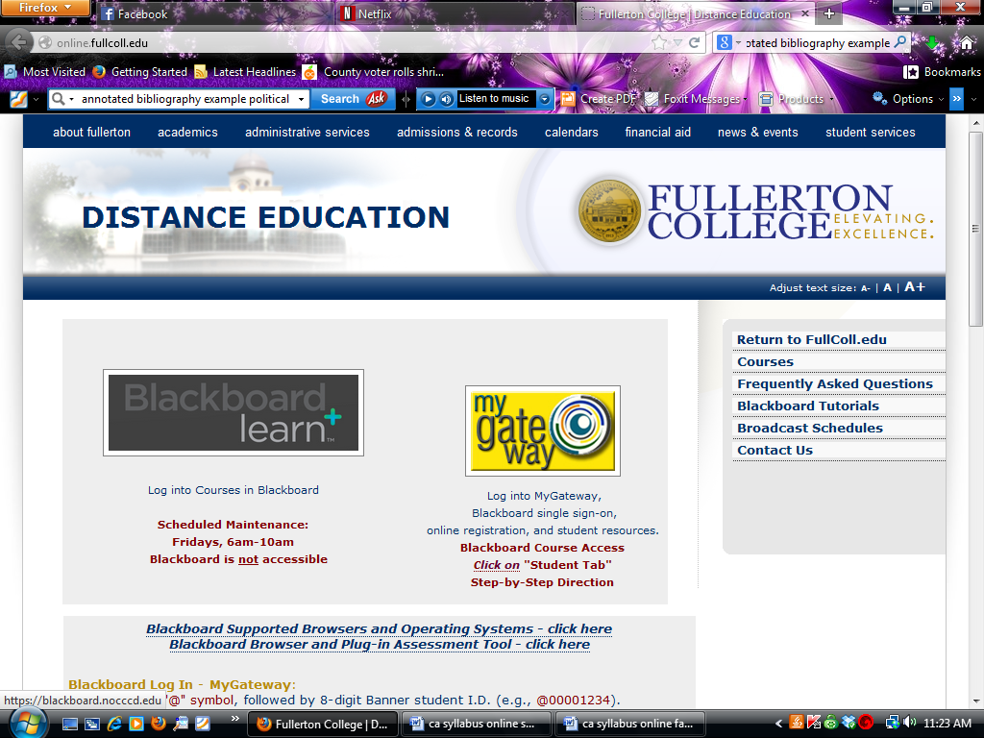

Blackboard Log In - MyGateway:
user name: "@" symbol, followed by 8-digit Banner student I.D.
(e.g., @00001234).
password: MyGateway/WebStar password

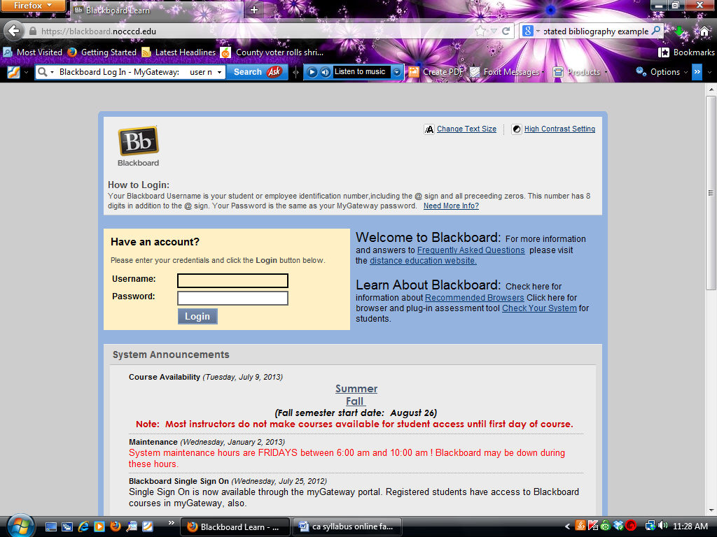

Technical Problems
Please remember that an online course is subject to technical problems. DO NOT wait until the last minute to finish exams or assignments. Students must have reliable and regular access to a computer and the internet. You should not rely on the computer lab on campus to take an online course, nor should you rely on your employer’s computer, since company computers often have firewalls and other safety features which present difficulties with the format of an online course.

For technical questions,

ACT Help Desk: 7am-8pm, Mon-Thur
email: helpdesk@fullcoll.edu 714-992-7111
Questions? email: online@fullcoll.edu
Please note that the FC Distance Learning Department helps students with technical (and browser) problems as a courtesy to students. It is the student’s responsibility to resolve his/her own technical problems. Students will not be allowed to make-up work or turn in late assignments because their computer “didn’t work” or because his/her browser wasn’t compatible with Blackboard.

http://online.fullcoll.edu/

